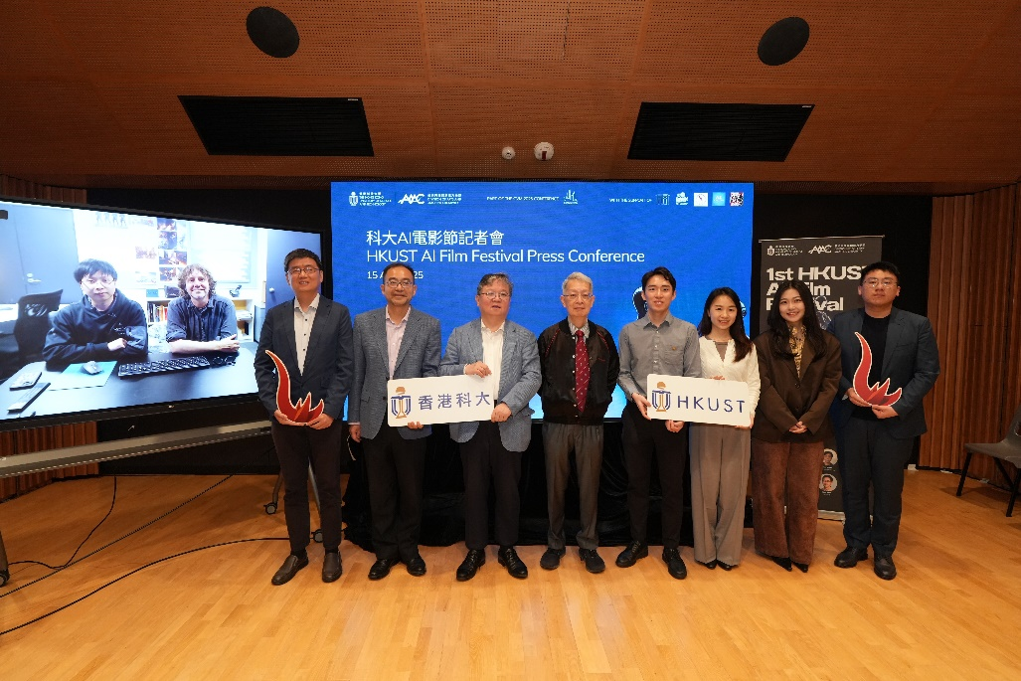 | HKUST organizes the first 100% AI-focused film festival in Greater China. A group photo of HKUST Provost Prof. GUO Yike (fifth left), Dean of the Academy of Interdisciplinary Studies (AIS) at HKUST Prof. Qu Huamin (fourth left), Acting Head of the Division of Arts and Machine Creativity (AMC) at HKUST Prof. FU Hongbo (third left), HKUST AMC Assistant Prof. RAO Anyi (fourth right), Wētā Workshop Art Director Mr. Jacky ZHENG (first left), Wētā Workshop 3D Artist and Technical Advisor Mr. Chris WILLIAMSON (second left), Honorary Advisor of the Hong Kong Society of Cinematographers Mr. Tony NGAI (fifth right), HKUST AMC Research Assistant Prof. XU Xian (third right); along with HKUST PhD students Ms. TANG Yuying (second right) and Mr. WEI Zheng (first right), who are among the participants of AIFF.
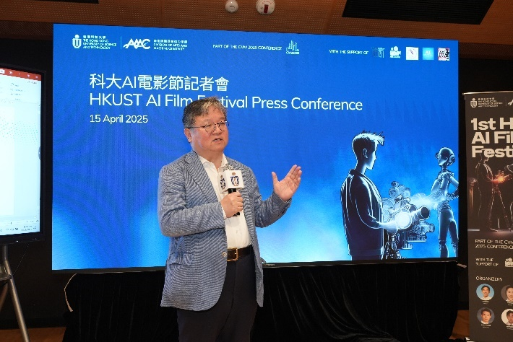 | Prof. Guo Yike delivers the opening remarks and shares insights into Art Tech development.
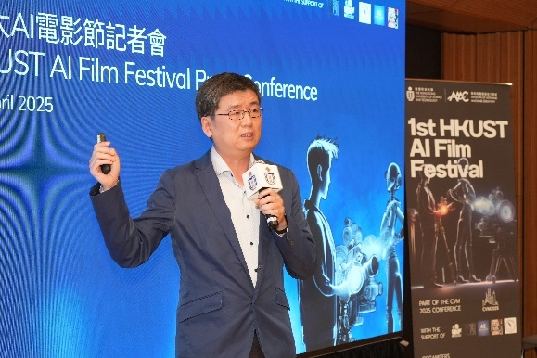 | Prof. Fu Hongbo shares the development of AMC since its establishment in July 2024.
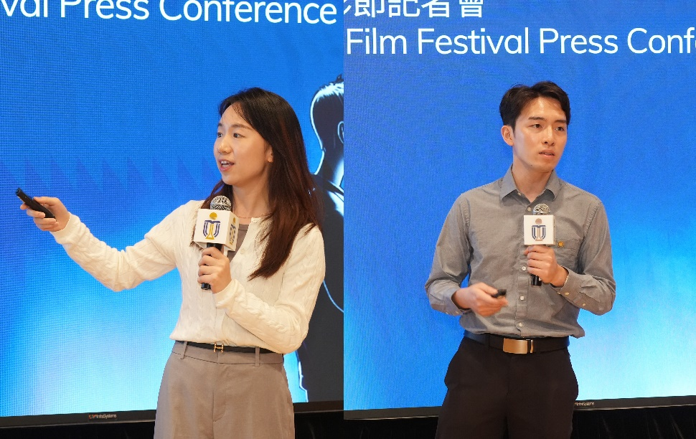 | Prof. RAO Anyi (right) shares details on AI Film Festival while Prof. XU Xian (left) presents on learning and teaching of Art-tech.
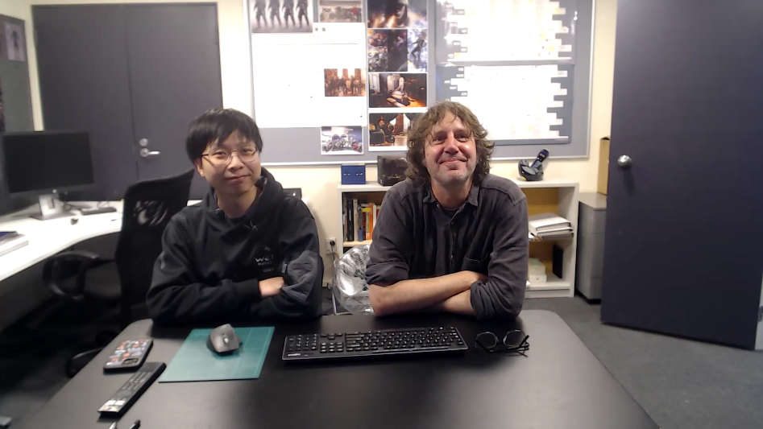 | Five-time Oscar winner Mr. Richard TAYLOR, known for his work on The Lord of the Rings, is one of the judges of AIFF. His team member Mr. Jacky Zheng and Mr. Chris Williamson join the press conference to share their judging criteria and discuss how AI is reshaping the international film industry.
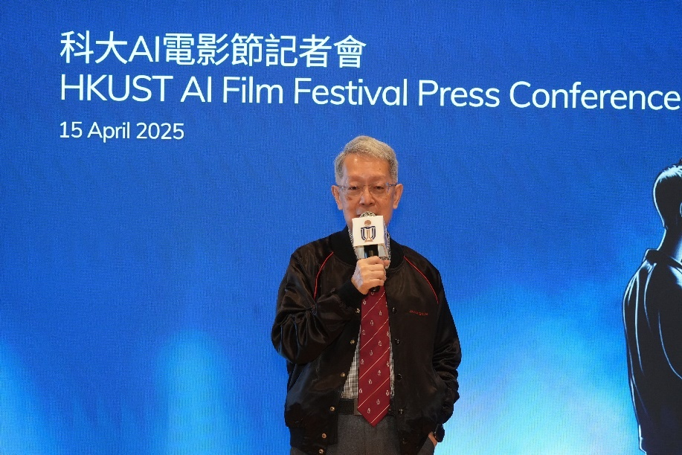 | Mr. Tony Ngai shares his 56 years of experience in the Hong Kong film industry and his views on how rapid technological changes influence the industry.
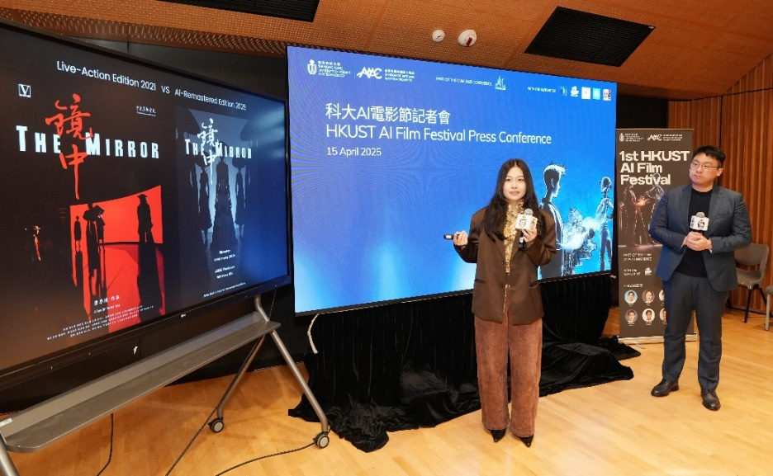 | A team from HKUST has been shortlisted as one of the 35 finalists for AIFF. PhD students Ms. TANG Yuying (left) and Mr. WEI Zheng (right) share their artwork and how AI influences their film production process.
A screencap of the trailer  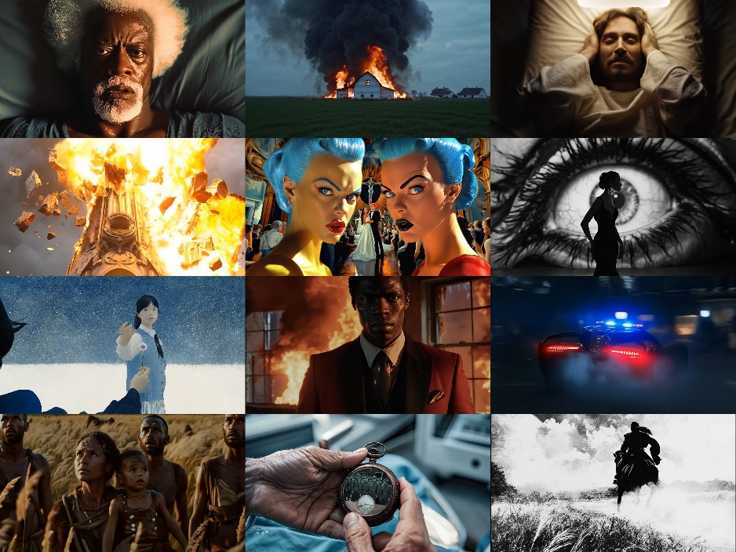 | Over 700 filmmakers, including award-winning directors, Emmy-nominated storytellers, established and emerging producers from over 80 countries and regions, submit their fully-AI generated artworks to the first 100% AI-focused film festival.

