Appendix I

Project details on HKUST Low Altitude Economy Research Center

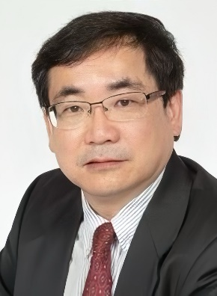 | Advanced Air Mobility  Prof. YANG Hai  - Chair Professor, Department of Civil and Environmental Engineering  - Associate Director of HKUST-MTR Joint Research Lab

Abstract
Prof. YANG Hai and his team have recently been awarded project titled “Development Strategies for an Advanced Air Mobility (AAM) Network in the Guangdong–Hong Kong–Macao Greater Bay Area” under the Strategic Public Policy Research Funding Scheme (SPPRFS). The project focuses on designing and evaluating AAM infrastructure for unmanned aircraft. The proposed HKUST sandbox will facilitate real-time testing of AAM concepts and aid in developing a 3D simulation framework to address operational challenges and promote AAM solutions in the region.

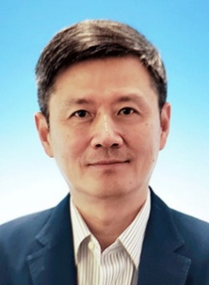 | Data Platform  Prof. ZHOU Xiaofang  - Head and Chair Professor, Department of Computer Science and Engineering  - Otto Poon Professor of Engineering

Abstract
Prof. ZHOU Xiaofang and his team are developing a robust data platform to serve as the infrastructure for OpenSILAS, the operational system supporting LAE. This team will monitor dynamic LAE data streams by consolidating information from UAV sensors, ground stations, and additional sources such as GIS and weather data, enabling efficient UAV operations that support LAE systems (e.g., OpenSILAS) and establishing the platform as a benchmark for future LAE technologies and applications.

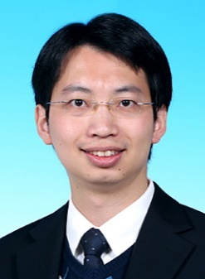 | Digital Twin  Prof. Jack CHENG Chin-Pang  - Associate Head and Professor, Department of Civil and Environmental Engineering  - Director of BIM Lab

Abstract
Prof. Jack CHENG and his team have conducted pioneering academic and applied research in various emerging scientific and technological fields. These include building management systems (BMS), the Internet of Things (IoT), AI, virtual reality/augmented reality, facility management and so on. Their work on 3D BIM models and geographic information system (GIS) data aids in managing UAV flight paths and monitoring activities. They also simulate UAV behaviors and assess their impact on the built environment for improved planning.

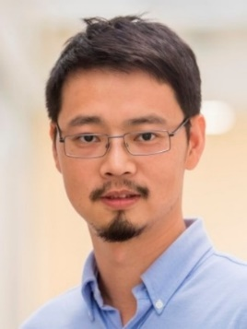 | UAV Application  Prof. LI Mo  - Professor, Department of Computer Science and Engineering  - Director of Low Altitude Economy Research Center

Abstract
Prof. LI Mo and his team are conducting a trial study on UAV-based emergency rescue to rapidly deploy medical equipment (e.g., AEDs, EpiPens) to remote areas, aiming to enhance emergency response by reducing delivery times. They are also studying ground-air communication systems and mission-critical operations for LAE to validate UAV reliability in challenging conditions, which will help develop robust network protocols and increase trust in UAV deployments for critical applications.

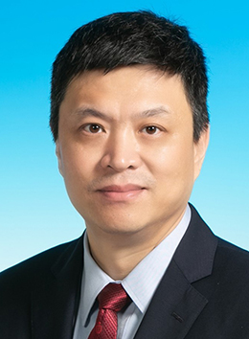 | UAV Research  Prof. ZHANG Fumin  - Acting Head and Chair Professor, Department of Mechanical and Aerospace Engineering  - Director of Cheng Kar-Shun Robotics Institute

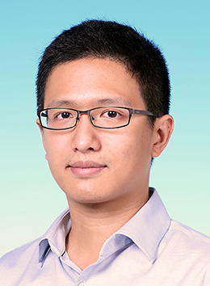 | UAV Research  Prof. SHEN Shaojie  - Associate Professor, Department of Electronic and Computer Engineering  - Director of HKUST-DJI Joint Innovation Laboratory

Abstract
Prof. SHEN Shaojie led the HKUST Aerial Robotics Group to develop fundamental technologies that enable aerial robots (UAVs, drones, etc.) to autonomously operate in complex environments. Their research covers key areas such as state estimation and mapping, environmental perception and understanding, prediction, motion planning and control, autonomous aerial exploration, and swarm systems. This group is part of the HKUST Cheng Kar-Shun Robotics Institute (CKSRI) under the leadership of Prof. ZHANG Fumin.

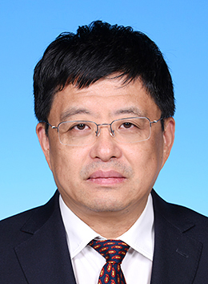 | Unmanned Aerial System Noise and Flight Safety  Prof. ZHANG Xin  - Chair Professor, Department of Mechanical and Aerospace Engineering  - Director of Aerodynamics and Acoustics Facility

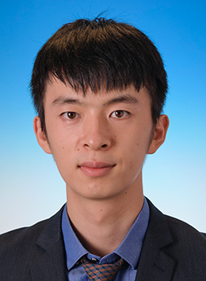 | Unmanned Aerial System Noise and Flight Safety  Prof. ZHOU Peng  - Research Assistant Professor, Department of Mechanical and Aerospace Engineering

Abstract
The Aerodynamics, Acoustics & Noise control Technology Centre (AANTC) led by Prof. ZHANG Xin and Prof. ZHOU Peng, focuses on UAS aerodynamics, noise, and flight safety in complex urban environments with challenging wind conditions. Their research aims to provide assessments of noise and flight safety. The AANTC also leads the development of UAS noise measurement standards and LAE noise regulations in collaboration with international and governmental organizations.

*Sort by project name (alphabetical order)

